
ATAR Chemistry – Unit 1 & 2
Note:
Use of notes allowed.
Notes must be your own work.
Hand your notes in with this assessment
Research Assignment 1 - Quiz
Heavy Water
Name:
Score: /25
Part 1: Multiple-choice (answer by neatly writing your response in the column to the right)
- Which of the following statements best describes a molecule of heavy water?
  - A molecule of water in which one of the hydrogen atoms has been replaced by a 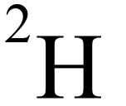 atom.
  - A molecule of water in which both of the hydrogen atoms has been replaced by  atoms.
  - A molecule of water in which the of the oxygen atom has been replaced by a 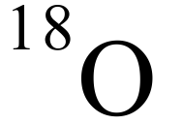 atom.
  - A molecule of water in which both of the hydrogen atoms has been replaced by  atoms and the oxygen atom is a  atom.
 | ₂
- Which of the following is a name for the hydrogen-1 atom?
  - Quadium
  - Tritium
  - Deuterium
  - Protium
 | ₂
- Which isotope is associated with heavy water?
  - Protium
  - Deuterium
  - Tritium
  - Quadium
 | ₂
- Of the following physical characteristics of heavy water compared to light water are true?
    - Lower melting point than light water
    - Higher boiling point than light water
    - Lower density in liquid form than light water
    - Higher density in solid form than light water
    - Same colour as light water
- i, iii, iv
- ii, iv, v
- ii, iii, iv, v
- iv, v
 | ₂
- The isotope of hydrogen in heavy water has an extra…
  - Proton
  - Electron
  - Neutron
- Neutron and electron | ₂

Part 2: Short answer (answer in the space provided)

- What is semi-heavy water? (2)

- Using one property as an example, explain why some properties of heavy water are different to light water. (3)

- Describe a method of producing heavy water. (2)

- Although not commonly known, the history of heavy water is intrinsically linked to World War II. Explain this link: (2)

- Is heavy water dangerous to living things? (2)

- Like hydrogen, oxygen also has several isotopes, the most abundant being 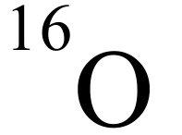, with 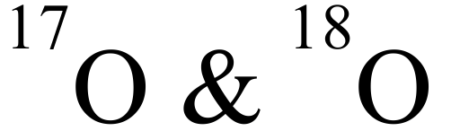 making up a very small proportion of all oxygen atoms. All three isotopes can be part of a water molecule.
How might the relative abundance of all three isotopes change (and a percentage of total mass) over time? Explain (4)

What is heavy water? (3)
Heavy water is water made with an isotope (1) of hydrogen called deuterium (1). This isotope of hydrogen has a heavier atomic mass due to an extra neutron (1).

What are the physical properties of heavy water? (5)
Melting and boiling points slightly higher than light water(1) due to extra neutrons (1), slightly higher density, especially as a solid (1) so that its ice does not float in water (1). Colour is the same (1)

What is semi-heavy water? And why is it unlikely to exist in a pure form as a liquid, but may as a solid? (3)
Has only one deuterium atom (1), due to self ionisation of water in liquid state, these atoms can be swapped between molecules (1). This is not likely to happen in the solid state.
How is heavy water produced? (4)
Either by centrifuge(1) heavier water is taken to the outside (1) or by electrolysis (1) where hydrogen gas is produced which is heavier (D₂), separated, the combusted with O₂ to produce D₂O (1)
When and where was heavy water discovered? (1)
1934 in ….
Describe the significance of heavy water to the Second World War. (2)
Nazi Germany thought it was part of the key to developing nuclear technologies (bombs). (2)

What is heavy water used for? (1)
As a moderator in nuclear fission reactors (1)
Are there any biological risks associated with heavy water? (1)
Has been shown to cause sterility (1)

